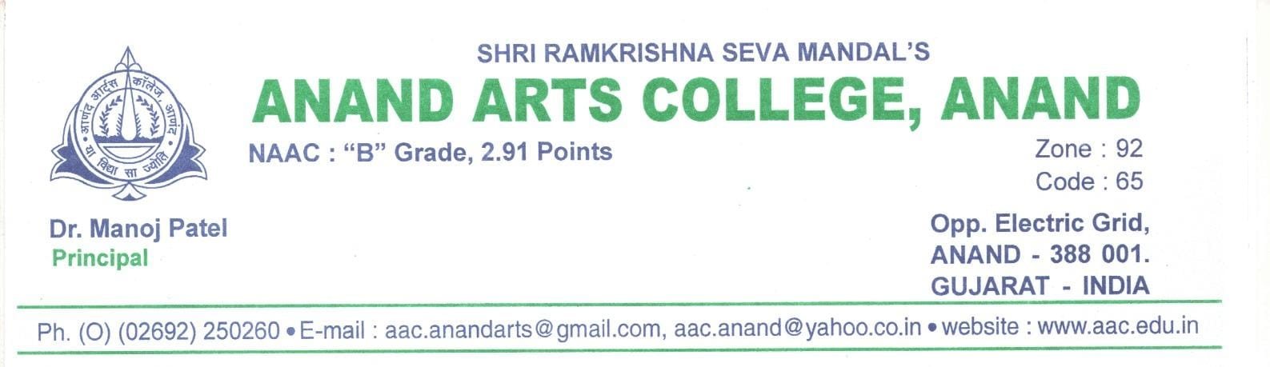

**Criterion-7 Institutional Values and Best Practices**

**Key Indicator-7.2 Best Practices**

**Matric No- 7.2.1**

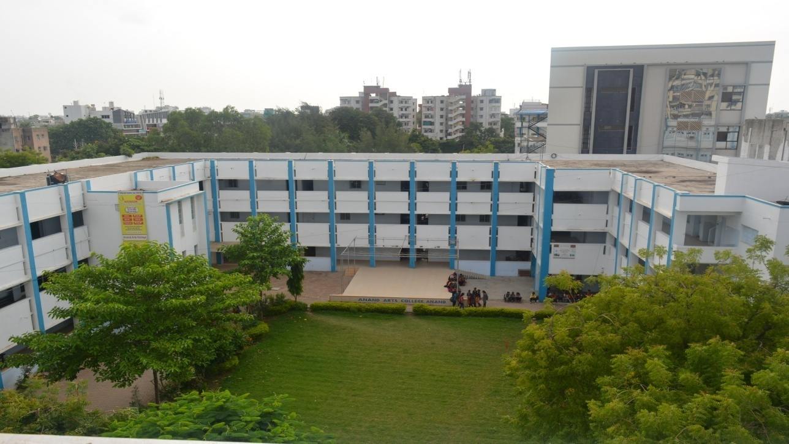

**OUR MOTTO: YA VIDYA SA JYOTI**



**7.2.1 Best Practices**

|  |  |  |
| --- | --- | --- |
| **Sr. No.** | **File Description** | **Web link** |
| **1** | **Eco-Harmony Club Activities** | [Open Link](https://aac.edu.in/wp-content/uploads/2024/02/ECO-HARMONY-PHOTOS-FINAL-1-1.pdf) |
| **2** | **Garden Maintenance Record** | [Open Link](https://aac.edu.in/wp-content/uploads/2024/02/eco-club-1.pdf) |
| **3** | **Mental Well-being through Yoga** | [Open Link](https://aac.edu.in/wp-content/uploads/2024/02/BROCHURE.pdf) |
| **4** | **Inculcating Spiritual Values** | [Open Link](https://aac.edu.in/wp-content/uploads/2024/02/BHAGVAD-GITA-2.pdf) |